**Design Document**

We modified several files to implement the required function.

In /usr/include/minix/callnr.h and /usr/src/include/minix/callnr.h head files, we add the definition of our method and allocated their address.

In /usr/src/lib/libc/sys-minix/ we created corresponding .c file to our own methods and added them to the makefile.inc to compile.

In usr/src/servers/pm/misc.c we add the details of these methods.

We designed six methods in misc.c file corresponding to six system calls.

The method do_topiccreate() will allow a process to declare itself a publisher of a specific interest group.

The method do_topiclookup() will allow a process to discover what interest groups are there.

The method do_topicpublisher() will allow a process to declare itself a subscriber to an interest group.

The method do_topicsubscriber() will allow a process to declare itself a subscriber to an interest group.

The method do_publish() will allow a publisher to send a message to an interest group.

The method do_retrieve() will allow a subscriber to retrieve one message from an interest group.

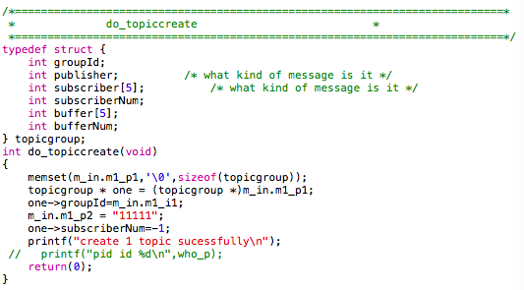

In order to implement the function required, we add a struct corresponding to several attributes.

We can create an interest group, and then add subscribers and publisher under the group. We can examine publish and retrieve function by calling do_publish() method and do_retrieve() method. Because the buffer can only contain 5 messages for each topic, when we publish the sixth message, it will not be added.

The welcome screen of the application

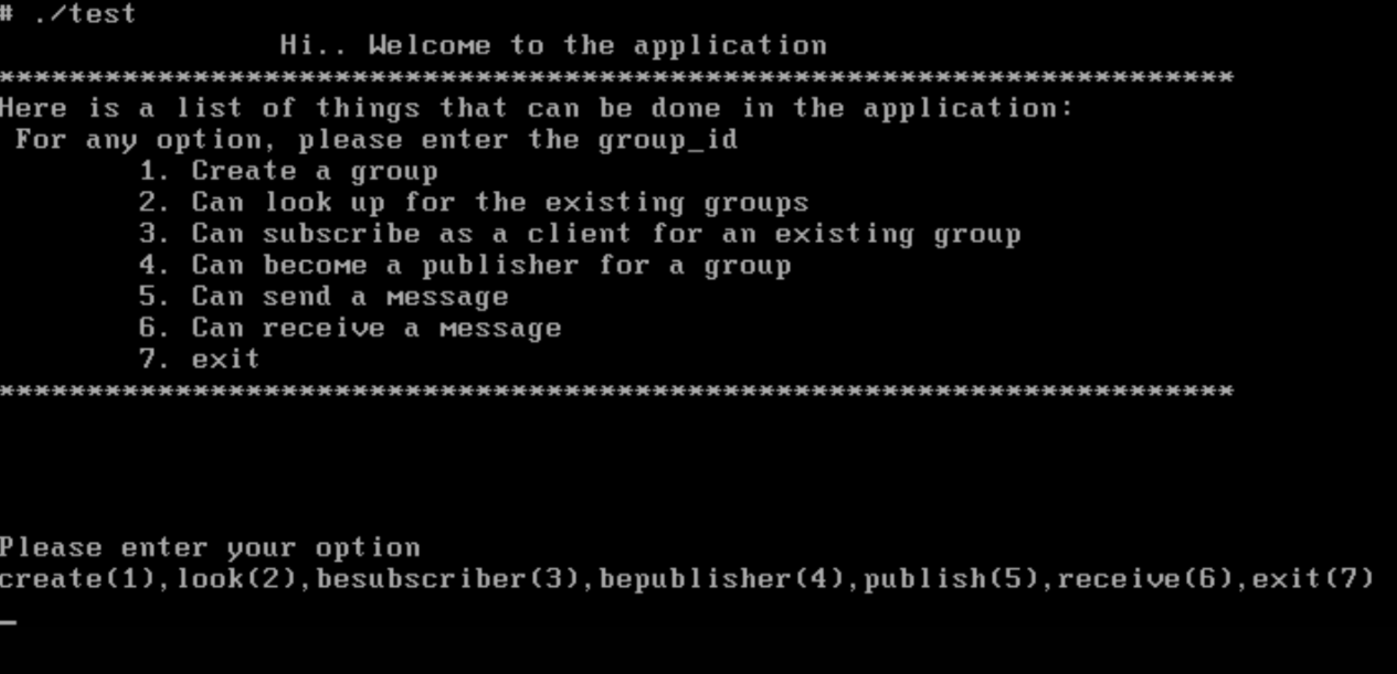

Topic create:

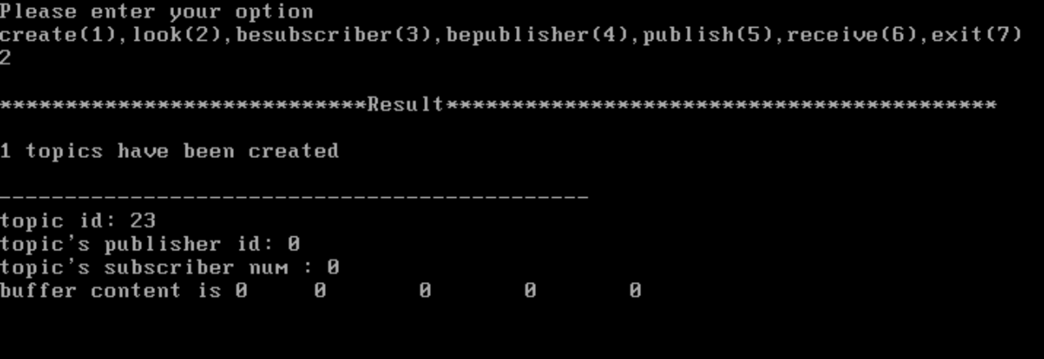

be the subscriber of the topic:

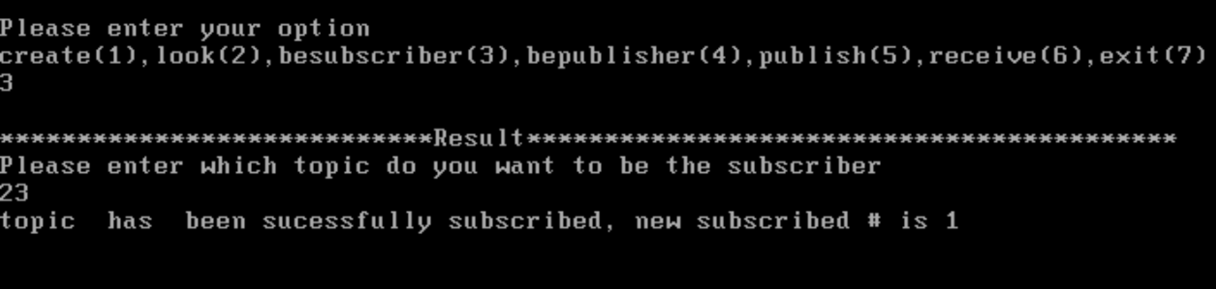

Be the publisher of the topic

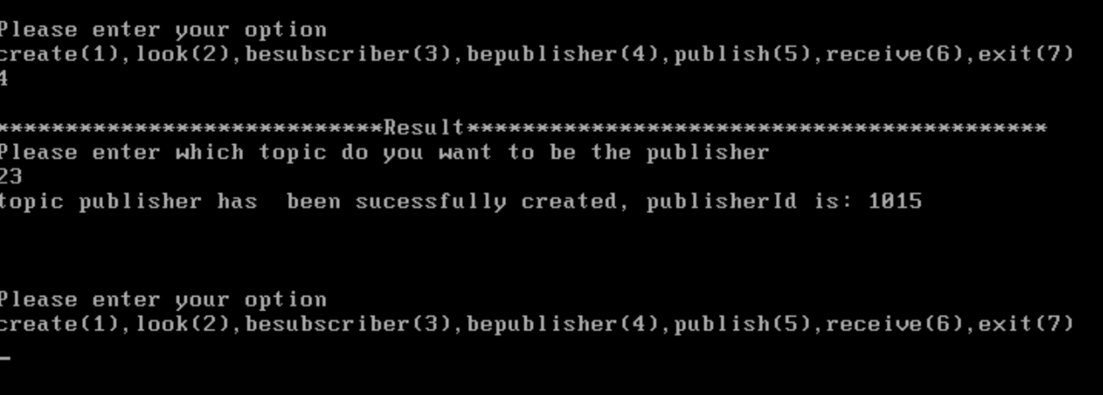

Publish the content to the topic

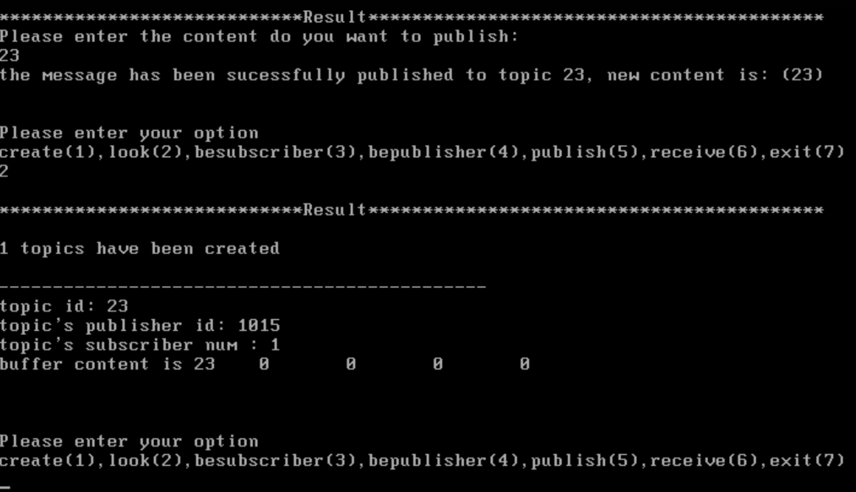

receive the message 